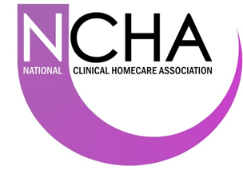
Project Proposal
Guidance note: This form should be completed by the assigned project lead or delegated party. The completed form should be saved as a Microsoft Word® document using the following naming convention: YYYYMMDD NCHA Project Proposal ‘Title of Project’.
The completed form should then be submitted to the NCHA Board – info@clinicalhomecare.co.uk
Project Proposal
Project Title:
Click here to enter text.
Prepared by:  Click here to enter text. | Contact details:  Click here to enter text. |  | Date:  Click here to enter text.
Project information
Project aim (short description):
Click here to enter text.
Provide reason for the project: Identify the problem to be addressed
Click here to enter text.
Project scope – IN  Click here to enter text. |  | Project scope – OUT  Click here to enter text.
Benefit
What is the benefit?  Click here to enter text. |  | Who benefits?  Click here to enter text.
Risks
What is the risk? (of inaction and action)  Click here to enter text. |  | Who bears the risk?  Click here to enter text.
Prioritisation
Legal, Governance & Compliance - Choose an item.
Clinical Outcomes - Choose an item.
Patient Benefits - Choose an item.
Efficiency / Cost saving - Choose an item.
Enabling Homecare Growth - Choose an item.
Additional information
Additional information:
Click here to enter text.

NCHA Board Decision – to be completed by NCHA Board
Project Sponsor:  Click here to enter text. | Date of decision:  Click here to enter text.
NCHA Board decision:
Choose an item.
Conditions and comments:
(e.g. ‘Approved subject to …’ or ‘Options appraisal required’)
Click here to enter text.

